**Linux Assignment -3**

1. Write a shellscript program for arithmetic operators using ‘expr’ and roundbraces?

The program for arithmetic operators using ‘expr’ and roundbraces

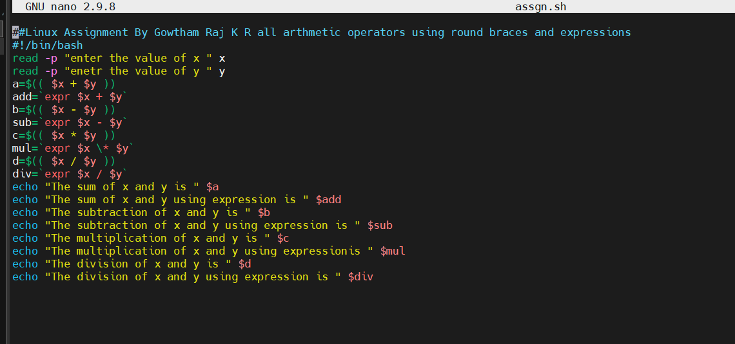

Output: -

